NITTE MEENAKSHI INSTITUTE OF TECHNOLOGY

(AN AUTONOMOUS INSTITUTION, AFFILIATED TO VISVESVARAYA TECHNOLOGICAL UNIVERSITY, BELGAUM, APPROVED BY AICTE & GOVT.OF KARNATAKA
PROJECT REPORT
On

DETECTION OF MALARIA IN BLOOD CELLS USING CONVOLUTION NEURAL NETWORK
Submitted in partial fulfilment of the requirement for the award of Degree of
Bachelor of Engineering
in
Computer Science and Engineering
Submitted by:
ANURAG NEPAL  AVISHEK RIJAL  BAIBHAV DHAKAL  SABIN KANDEL | 1NT19CS036  1NT19CS045  1NT19CS048  1NT19CS165

Under the Guidance of
Dr. Nalini N
Professor(CSE) & Dean-Students’ Welfare,
NMIT, Bangalore

Department of Computer Science and Engineering
(Accredited by NBA Tier-1)
2022-2023

NITTE MEENAKSHI INSTITUTE OF TECHNOLOGY
(AN AUTONOMOUS INSTITUTION, AFFILIATED TO VISVESVARAYA TECHNOLOGICAL UNIVERSITY, BELGAUM,
APPROVED BY AICTE & GOVT.OF KARNATAKA)
Department of Computer Science and Engineering
(Accredited by NBA Tier-1)

CERTIFICATE
This is to certify that the Detection of Malaria in Blood Cells Using Convolution Neural Network is an authentic work carried out by Anurag Nepal(1NT19CS036), Avishek Rijal(1NT19CS045), Baibhav Dhakal(1NT19CS048) and Sabin Kandel(1NT19CS165) bonafide students of Nitte Meenakshi Institute of Technology, Bangalore in partial fulfilment for the award of the degree of Bachelor of Engineering in COMPUTER SCIENCE AND ENGINEERING of Visvesvaraya Technological University, Belgavi during the academic year 2022-2023. It is certified that all corrections and suggestions indicated during the internal assessment has been incorporated in the report. This project has been approved as it satisfies the academic requirement in respect of project work presented for the said degree.

Internal Guide |  | Signature of the HOD |  | Signature of Principal
Dr. Nalini N.  Professor(CSE)  Dean-Students’ Welfare,  NMIT Bangalore |  | Dr. Vijaya Shetty S.  Professor & Head(CSE),  Dept. CSE, NMIT Bangalore |  | Dr. H. C. Nagaraj  Principal,  NMIT, Bangalore
 | Signature of Examiner (Internals) |  | Signature of Examiner (SEE)

DECLARATION
We hereby declare that
(i) The project work is our original work
(ii) This Project work has not been submitted for the award of any degree or examination at any other university/College/Institute.
(iii) This Project Work does not contain other persons’ data, pictures, graphs or other information, unless specifically acknowledged as being sourced from other persons.
(iv) This Project Work does not contain other persons’ writing, unless specifically acknowledged as being sourced from other researchers. Where other written sources have been quoted, then:
a) their words have been re-written but the general information attributed to them has been referenced;
b) where their exact words have been used, their writing has been placed inside quotation marks, and referenced.
(v) This Project Work does not contain text, graphics or tables copied and pasted from the Internet, unless specifically acknowledged, and the source being detailed in the thesis and in the References sections.

NAME | USN | Signature
ANURAG NEPAL | 1NT19CS036
AVISHEK RIJAL | 1NT19CS045
BAIBHAV DHAKAL | 1NT19CS048
SABIN KANDEL | 1NT19CS165

Date:

ACKNOWLEDGEMENT

The satisfaction and euphoria that accompany the successful completion of any task would be incomplete without the mention of the people who made it possible, whose constant guidance and encouragement crowned our effort with success. I express my sincere gratitude to our Principal Dr. H. C. Nagaraj, Nitte Meenakshi Institute of Technology for providing facilities.

We wish to thank our HoD, Dr. Vijaya Shetty S. , Professor & HOD(CSE),NMIT, Bangalore for the excellent environment created to further educational growth in our college. We also thank her for the invaluable guidance provided which has helped in the creation of a better project.

I hereby like to thank our guide Dr. Nalini N., Professor(CSE) & Dean-Students’ Welfare, NMIT, Bangalore on her periodic inspection, time to time evaluation of the project and help to bring the project to the present form.

Thanks to our Departmental Project coordinators. We also thank all our friends, teaching and non-teaching staff at NMIT, Bangalore, for all the direct and indirect help provided in the completion of the project.

NAME | USN | Signature
ANURAG NEPAL | 1NT19CS036
AVISHEK RIJAL | 1NT19CS045
BAIBHAV DHAKAL | 1NT19CS048
SABIN KANDEL | 1NT19CS165

Date:

ABSTRACT

Although numerous automated diagnostic techniques and models have been developed using supervised learning models primarily to cater to western diseases such methods are rarely used to spot outbreaks of illnesses like dengue or malaria. However early detection is vital in mitigating the mortality rate associated with such diseases. Therefore our project seeks to tackle this problem by developing a highly efficient automated diagnostic model that utilizes machine learning algorithms for detecting malaria in blood cells while keeping track of disease progression. As there’s currently no cure for Malaria yet detecting it at its earliest stages offers patients hope by allowing medical professionals assess their risk levels thereby making informed decisions on their treatment options. In addition diagnosis delays could be critical since some countries lack essential medical resources capable of taking fast action against disease outbreaks; hence the need for an effective solution like our mobile application which integrates a low cost microscope like a foldscope which is a pocket microscope costing about a dollar with our machine learning model to give fast and accurate diagnosis.

TABLE OF CONTENTS
ABSTRACT v
ABBREVIATIONS ix
CHAPTER 1 :INTRODUCTION 1
1.1 Background 2
1.1.1 Malaria 2
1.1.2 Statistics about Malaria 3
1.1.3 Methods to detect Malaria. 3
1.2 Brief History of Technology/Concept 4
1.2.1 Machine Learning 4
1.2.2 Foldscope 5
1.3 Research Motivations and Problem Statement 7
1.3.1 Research Motivations 7
1.3.2 Problem Statement 7
1.4 Research Objectives and Contributions 8
1.5 Organization of the Report 8
1.6 Summary 9
CHAPTER 2: LITERATURE SURVEY 10
2.1 Introduction 11
2.2 Related Works 11
2.3 Tools/Technology Used 13
2.4 Summary 13
CHAPTER 3 : SYSTEM REQUIREMENTS SPECIFICATIONS 14
3.1 General Description 15
3.1.1 Product Perspective 15
3.2 System Requirements 15
3.2.1 Hardware Requirements 15
3.2.2 Software Requirements 15
3.2.2.1 Functional Requirements & Non-Functional Requirements 16
3.2.2.2 User Requirements 16
3.3 Summary 17
CHAPTER 4 : DESIGN 18
4.1 Architectural Design 19
4.2 Dataflow Diagram 20
4.3 Usecase Diagram 21
4.4 Activity Diagram 21
CHAPTER 5: IMPLEMENTATION 23
5.1 Methodologies 24
5.2 Description of Process 25
CHAPTER 6: RESULTS 27
6.1 Model Architecture 28
6.1.1 First Attempt 28
6.1.2 Second Attempt 30
6.2 Android Application 33
6.3 Webapp 36
CHAPTER 7: IMPACT OF OUR PROJECT TOWARDS SOCIETY/ ENVIRONMENT 39
CHAPTER 8 : CONCLUSIONS 41
CHAPTER 9: REFERENCES 43
APPENDIX-I: PAPER WITH CERTIFICATES 46
APPENDIX-II:PLAGARISM REPORT 47
APPENDIX-III: SELF ASSESSMENT OF PO-PSO ATTAINMENT 48

TABLE OF FIGURES

Figure 1 Five Plasmodium Species and their life stages 2
Figure 2 Malaria Death Rate 3
Figure 3 Parasite in blood smear 4
Figure 4 Images from a Foldscope 6
Figure 5 Photos from a foldscope 7
Figure 6 System Architecture 19
Figure 7 Dataflow Diagram 20
Figure 8 Use case Diagram 21
Figure 9 Activity Diagram 22
Figure 10 Application Architecture 24
Figure 11 Workflow of the Application 25
Figure 12 Validation Accuracy and Loss of the First Model 28
Figure 13 Model Architecture of the First Attempt 29
Figure 14 Model Architecture of Second Attempt 31
Figure 15 Validation Accuracy of the Second Model 32
Figure 16 Confusion Matrix 33
Figure 17 Welcome Screen 34
Figure 18 Choose Smear Type 34
Figure 19 Thick Smear Blood Sample 34
Figure 20 Collect Patient Info 35
Figure 21 Collect Slide Info 35
Figure 22 Report Summary 35
Figure 23 Database 35
Figure 24 Slide Info 35
Figure 25 Slide Info with both smear types 35
Figure 26 Realtime Malaria Data 37
Figure 27 Webapp Predict Page 37
Figure 28 Tracking the Progression of the Disease 38

ABBREVIATIONS

WHO : World Health Organization
CNN : Convolution Neural Network
P. : PARASITE
SVM : Support Vector Machine
RBC: Red Blood Cell
WBC: White Blood Cells
CSV: Comma Separated Value

CHAPTER 1 :

INTRODUCTION

Background

Malaria
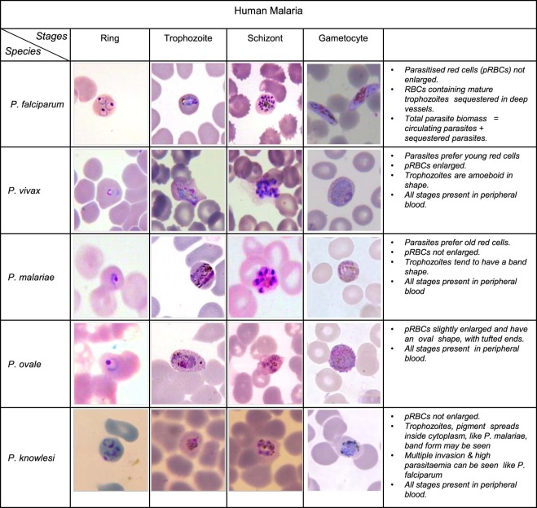
Malaria is caused through the bites of infected female Anopheles mosquitoes, which transmit the protozoan parasites of the genus Plasmodium and that infects the red blood cells and is still considered as a major health problem in the world. About 40% of the world population are exposed to Plasmodium parasites as pictured in Figure 1, of which Plasmodium falciparum and Plasmodium vivax are most dominant and WHO still recognizes malaria as an endemic[1]. Despite efforts being made to control and eradicate malaria, it remains a life-threatening disease, particularly in developing African and Asian countries where less accessibility to proper and quality health services are the contributing factors . Poor living conditions and the increase in freak weather conditions certainly help in spreading the disease and making it life threatening.

Figure 1 Five Plasmodium Species and their life stages

Statistics about Malaria
Despite the reduction in deaths and cases of malaria in the developing , still an estimated 214 millions of cases are seen every year with it claiming more than 400 thousand lives. Most of the people suffering from malaria can be found in just 20 countries with higher intensity shown in Figure 2, where the morality is more dominant in Sub-Saharan African Countries like Nigeria , Congo etc[1]. The main problem these countries have is that they cannot sufficiently fill the gaps in their health care systems which starts with early diagnosis of the disease. While the economic burden of detecting and caring for malaria is in billions, there is no improvement in the lives of people in these countries.
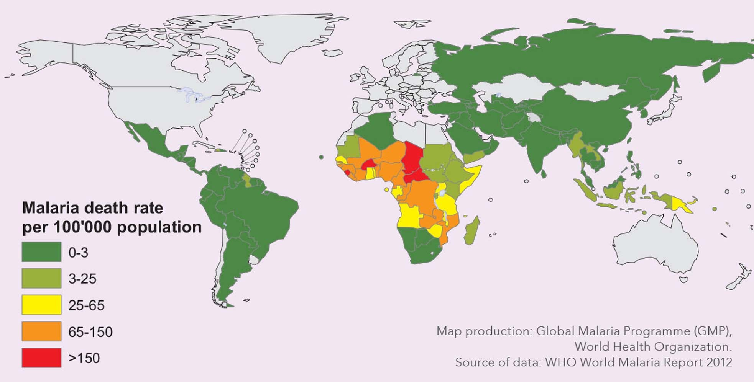
Figure 2 Malaria Death Rate

Methods to detect Malaria.
There are several methods that can be used to diagnose malaria. Polymerase chain rection or PCR can be used to show a higher sensitivity to detect the parasite but it is a complex and high cost per test technology. Similarly fluorescent microscopy can be used to detect to detect the parasite under fluorescent light but it is also very costly. That is why manual microscopy is widely used for the detection. Manual microscopic detection of malaria is performed by visual inspection after Giemsa staining, procedure used to highlight the parasite where the stained blood smears into thick and thin blood smears. The thick blood smears ,which are prepared with thick layer of blood on the slide, are mainly used for the detection of malaria parasites. But with thick blood smears clear visibility and differentiating the RBC’s from other components of blood like WBC’s and Platelets prove to be major problems. That can be overcome by the thin blood smears which can be used for detailed examination such as the parasite type and the stage of the disease. But the lack of expertise and feasibility to afford microscope can hamper the early diagnosis in rural and endemic regions.

But for automated diagnosis of malaria the image like that in Figure 3 of the blood smears are to be obtained from a microscope or in our case , to keep the cost low, a foldscope. Different kinds of smears can be used to properly develop and train the model for malaria detection. After the images are acquired and processed as the required form it can be run through the model to detect if there is malarial parasite in the blood or not.
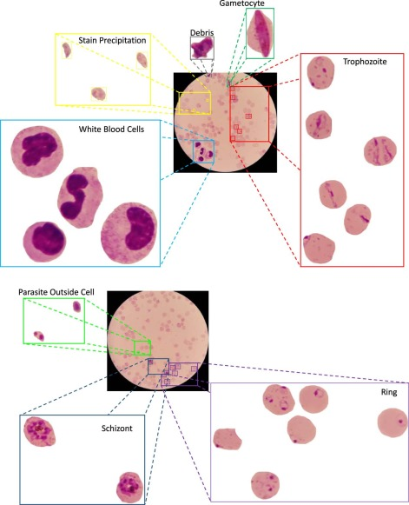
Figure 3 Parasite in blood smear

Brief History of Technology/Concept

Machine Learning
Machine learning is a type of artificial intelligence that allows a model or a software or an app to learn and be more accurate in predicting outcomes of certain things without being programmed explicitly [4]. Machine learning algorithms (generally supervised learning) develop models that use historical data as input and analyze it to predict new output values.
Historical data in simple terms refers to collected data of a particular event or a circumstance usually pertaining to a particular subject or a context. Historic data can be of anything, from texts to numbers to images and even videos. These types of data don't make much sense when viewed by a human but using machine learning algorithms we can make the predictions based on recurring patterns and similarities.
Historical data is generally very messy and very abundant. A model can only do faster computation if the data is normalized and easy to understand. Data in the real world is not organized, mostly heterogenous, messy and has missing entries [2]. Before trying to make sense of the data it must be cleaned and optimized so that when a machine learning model or an algorithm tries to analyze it, it finds the appropriate outcome or result [5]. This preprocessing of data is very vital for creating a machine learning model. Data must be cleaned i.e.; any outliers or missing data should be dealt with using appropriate measures. Data transformation is also necessary as some data are very unstructured [3]. We need to make it better organized. Transformed data is easier to use for both humans and computers. [6] It increases efficiency and results in faster prediction or calculation of output.
Along with data, machine learning is highly dependent on math’s, mostly linear algebra, calculus, and statistics [3]. We need to understand the depth of the algorithm and math’s behind it because a computer processes information differently than us [7]. The algorithms we use for machine learning are made using mathematical prerequisites. We need to understand the working of the algorithm by analyzing and understanding the mathematical functions behind it. Doing so helps us in understanding the parameters that are fine-tuned to achieve an optimal model. Since no model is fully accurate when tested in real time, thus, to make a strategic decision we must change the parameters of the mathematical equations and optimize it according to our need.

Foldscope
The basic principle is using a small circular lens caught near the eye comes from Antoine van Leeuwenhoek (1632–1723), who was the first to see single-celled organisms using a lens caught in a machine of his design. Foldscope, as pictured in Figure 4, was developed by a team led by Manu Prakash, an assistant professor of bioengineering at Stanford School of Medicine [8]. The project was funded by several organizations including the Bill & Melinda Gates Foundation, which provided US $ 100,000 in funding for research in November 2012[9].
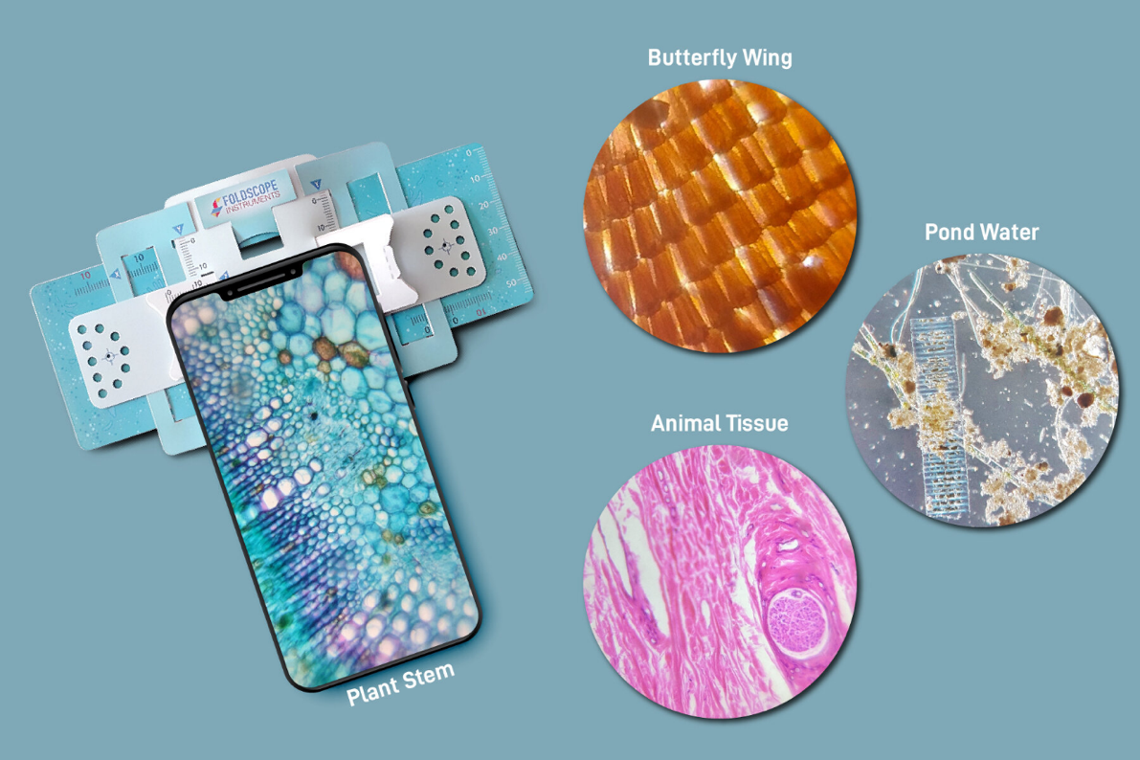
Figure 4 Images from a Foldscope

The Foldscope is an optical microscope that can be integrated from a cardstock flipchart sheet, a round glass lens, a light emitting diode (LED) and diffuser panel, and a battery-powered watch battery. When combined, the Foldscope is about the size of a bookmark [9]. The Foldscope weighs 8 grams and comes with a lens that expands 140X [9]. However, using the phone camera and zoom can make it expand the 1400X [9].
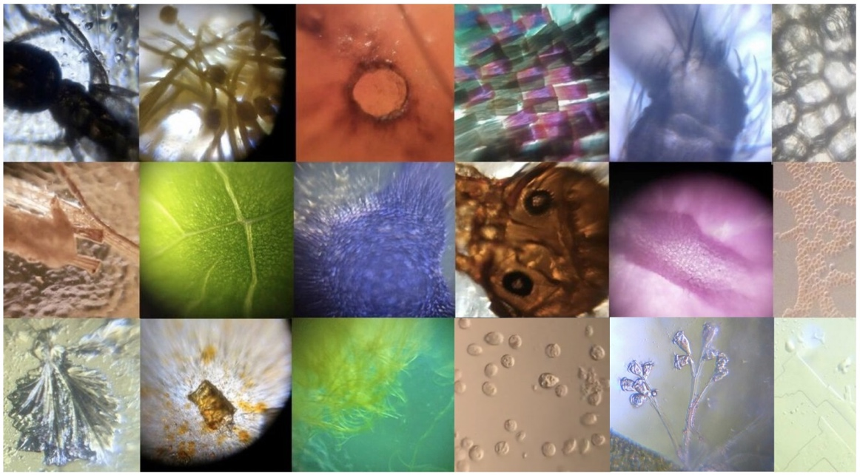
Figure 5 Photos from a foldscope

Research Motivations and Problem Statement

Research Motivations
Several researchers have developed various models to identify and diagnose diseases such as Parkinson's, COVID-19, and hypertension. However, these disease detection models have primarily been tailored towards western developed countries, leaving developing countries behind. Consequently, diseases like malaria, which continue to be a significant public health concern and claim numerous lives in these regions, remain undetected.
While traditional methods for detecting malaria, such as light microscopy or chemical detection, exist, they are time-consuming and expensive for individuals living in these areas. To address this issue, we are exploring the use of microscopic images of blood smears to diagnose and detect malaria, which could potentially offer a more affordable and accessible solution for individuals living in developing countries.

Problem Statement
Our primary objective is to collect blood smear images from Microscopes and apply suitable machine learning algorithms to identify the presence of malarial parasites in blood and track their progression for improved diagnosis. It is important to note that our project is not intended to replace traditional testing methods. Rather, it aims to alleviate the economic burden associated with such procedures. We plan to achieve this by utilizing cost-effective pocket microscopes and readily available, affordable Android smartphones to detect parasites in blood samples.

Research Objectives and Contributions
Although our project has many ambitious goals, its primary objectives can be summarized as follows:
- Develop an automated malaria diagnosis application using machine learning and deep learning models that can accurately diagnose vector-based diseases.
- Create a responsive application that can efficiently process images from a foldscope and provide real-time analysis and prediction of malaria parasites in blood samples.
- Reduce the computational complexity of the prediction models so that the mobile application can be used on Android phones with the lowest specifications.
- Provide health professionals in rural areas with an improved diagnostic tool that can help save lives by accurately detecting the presence of malaria parasites in blood samples.

Organization of the Report
This report is organized into four chapters and a brief description is given as follows:
Chapter 1 gives the overview on malaria; it is impact on the developing world and the research motivation that has made up take up this challenge. In this chapter we also explain about the tools and algorithms we are going to be using to tackle this problem. We also have listed out the objectives that we hope to achieve at the completion of this project.
Chapter 2 gives the overview of the research that was conducted by us with reading other literature. The studies that have helped us get to this point are listed in the chapter 2. In this we investigated other related works on detecting parasites and the models that they used.
Chapter 3 contains the Hardware and Software requirements for the neural network and the mobile application.
Chapter 4 provides the insights into the architectural designs of the application and the neural network.
Chapter 5 provides the insights into the implementation of the application and the modules.
Chapter 6 gives the results of the neural network; it is accuracy and the loss. Also, there are the screenshots of the android and the webapp.
Chapter 7 encompasses the impact of our project towards society and the environment.
Chapter 8 is the conclusion we made during the time we spent doing the research and what we hope to achieve with this project.
Chapter 9 gives the list of references we used to complete this paper.
Appendix-I has the certificate of the paper published in ERCICA.
Appendix-II has the plagiarism checked report of this project report.
Appendix-III has the self-assessment of PO-PSO attainment of the project.

Summary
To wrap things up with this chapter, we come to know that malaria still is an endemic in the world that is claiming lives and that has motivated us to take up this project. Also using machine learning can help in reducing the time it takes to manually give the test results to each individual and this can help in saving as much time during the detection and give more time for an effective diagnosis. We also saw the description of the foldscope, its capabilities in taking microscopic pictures that how that can help us detect malaria in the blood. We hope to make a small light application that in addition to a foldscope can help detect malaria.

CHAPTER 2:

LITERATURE SURVEY

Introduction
Our objective is to develop an application capable of detecting malarial parasites in blood smears using an accessible and affordable foldscope. By attaching the foldscope to a mobile phone and utilizing our application, we aim to achieve real-time detection of malarial parasites in blood samples. We have researched the previous works of various researchers and scientists, who have employed machine learning and advanced image analysis techniques to create mobile diagnosis systems. However, the earlier applications were complicated and inefficient, and there has been no recent development in this field.
With the latest advancements in algorithms and increased processing power in mobile phones, we are determined to create a highly efficient mobile diagnostic system for detecting malarial parasites in blood samples. Our goal is to overcome the challenges faced in traditional testing methods and provide a reliable solution for the timely detection of malaria in developing regions.

Related Works
Pirnstill and Cote (2015) presented malaria detection using a polarized microscope[11]. They used an inexpensive cell phone based on the idea of a polarized microscope to take samples, in which they were able to see the hemozoin. Hemozoin is a dirty product that is formed after staining the blood. Their cell phone, based on a polarized microscope, was able to take a picture and detect malaria.
Breslauer et al. (2009) introduced a cell phone-based microscope for global health applications, including malaria. Use of microscope attachments helped in advanced adjustments for the mobile camera. A microscope and a mobile camera can capture bright light and the fluorescent image. They used a bright digital image and a blood smear image and were able to identify the malaria parasite. Their system was able to detect malaria parasites thick blood smears and differentiate them with red blood cells.
Rosado et al. (2016) introduced the automatic detection of malaria parasites in blood smears using mobile camera. They used a machine-readable study method, the SVM (vector machine) class, to test the presence of P. falciparum trophozoites and the WBC in Giemsa stains by testing thick blood smears for blood tests. While WBC detection achieved 98.2% sensitivity and 72.1% specificity, P. Falciparum trophozoite detection achieved 80.5% sensitivity and 93.8% specificity.[10]
Quinn (2014) presented an automated blood smear analysis for cellular malaria. With design of a 3-D printable adapter i.e. adapter that attaches a cell phone to any type of microscope. With the help of cell phone, they were able to take pictures of blood smears. They also provided a workflow for automatic blood smear testing that includes morphologic and temporal calculation and a combination class of training trained in these tasks to distinguish themselves from the strange fragments containing parasites and common episodes.
Skandarajah et al. (2014) designed and developed a multimedia based microscope. Their microscope design is compatible with all major cell phones from any manufacturers. They introduced their microscope cell phone and created a multimedia microscope with a light microscope like resolution. Phones with 5 or more-megapixel cameras have the ability to produce unlimited diffraction adjustments that compatible to take a single cell image.
Dallet et al. show an android mobile app that can detect and detect malaria in the given blood cultures . This app is based on the annular ring ratio method. In this way, the app detects red blood cells and white blood cells and detects whether malaria parasites are present in red blood cells. It can also classify different categories of parasites and calculate the spread of infection.
Cesario et al. describe in detail cell-based solutions and support for animal diseases in areas where health care services are limited. They focus mainly on image classification and analysis, in which remote diagnoses of the rarest diseases are performed[12]. This reduces the burden on health workers and reduces the risk of misdiagnosis of rare diseases. Their work in developing and implementing image analysis and classification in the medical field has received constructive feedback from health professionals.
Shah et al. present an in-depth study of how you can identify malaria in blood cells . They use the convolution neural network (CNN) to differentiate between infected and healthy blood samples. Their model works with minimal resources and has a low calculation time that provides instant results. The CNN separator used contains a number of flexibility layers with a few filters that show good accuracy even under low-level resources. Their CNN algorithm is 95% accurate and operates with limited resources.

Tools/Technology Used
Our project aims to detect malaria parasites in each blood smear by employing Convolutional Neural Networks (CNN). To accomplish this, we begin by processing the high-quality microscopic image of the blood sample and applying image processing techniques to obtain its absolute dimensions while preserving its crucial features. To enable real-time analysis and malarial parasite detection, we further normalize and reduce the image size for quicker computation. By employing CNN, we can accurately identify whether a blood sample contains malaria parasites. We also intend to utilize image segmentation to locate the parasites in the given blood sample. CNN is a deep learning algorithm that assigns significance to different aspects or objects in an image, enabling it to distinguish between them and capture the spatial and temporal dependencies in the image through contextual filters. Its architecture significantly reduces the number of parameters, improving the accuracy of image datasets and allowing for reusability of the weights.
Support Vector Machines (SVMs) are widely preferred and respected for their ability to produce significant accuracy with low computational power. SVMs can be used for classification, regression, and anomaly/outlier detection. Developed by Waapnik and colleagues at AT&T Bell Laboratories, SVM constructs hyperplanes over a high or infinite dimensional space for classification or regression and utilizes mathematical operation-based kernels. In the past, SVM classifiers have been used to detect the presence of P. Falciparum trophozoites (parasites that cause malaria) and white blood cells (WBCs) in blood smear samples. Researchers have employed a Gaussian RBF kernel, tuned Gamma and C hyperparameters, and achieved high accuracy and sensitivity. C is a hyperparameter used for error control, while Gamma defines the curvature weights of the decision boundary. For instance, Rosado et al. (2016) developed an SVM model that detected WBC with 94.9% accuracy and P. Falciparum trophozoites with 91.8% accuracy, with limited resources and an average computational time on a mobile phone of 44 seconds.

Summary
It is evident that the bulk of the current research in this field is carried out using large and expensive microscopes, whereas our approach involves using an affordable and accessible foldscope. Furthermore, it has been observed that CNNs have yielded higher accuracy than SVMs in parasite detection, and hence we will be adopting this algorithm in our approach.

CHAPTER 3 :

SYSTEM REQUIREMENTS SPECIFICATIONS

General Description
The aim of this project is to develop an android application that utilizes a machine learning model for diagnosing malaria from blood smears. The application allows users to capture an image of a blood smear using a Foldscope and then uses the image for malaria diagnosis. The target audience for this application is individuals from developing countries where other blood culture methods such as RDT take longer to provide results and where environmental conditions like heat and humidity can hinder diagnosis.

Product Perspective
The application we are developing has the following main features:
- Camera Section: This feature allows the user to capture an image of the blood smear directly from the app, which can be used for diagnosing malaria.
- Photo Section: If necessary, the user can select images from the gallery for diagnosis purposes.
- Offline Computation: Our application aims to provide offline computation for the detection of malaria parasites in blood smears. While it is possible to store data in online databases, the app is designed to operate in offline mode and provide outputs accordingly.

System Requirements

Hardware Requirements
- Android Device with 2GB or more RAM
- Any newer version of Snapdragon or MediaTek Processors
- Foldscope

Software Requirements
- Python 3.7 and above
- TensorFlow
- Keras
- OpenCV

Functional Requirements & Non-Functional Requirements
The functional requirements for our mobile diagnostic system are as follows:
- Provide users with the ability to take pictures of blood smears
- Allow users to choose pictures from their gallery if the camera is unavailable
- Utilize machine learning algorithms to detect the presence of malarial parasites in the blood smears
- Indicate whether or not malarial parasites are present in the blood smears
In addition to these functional requirements, we have identified several non-functional requirements that are critical to the success of our system:
- Availability: The system must be available offline to support malaria diagnosis in rural areas
- Reliability: The system should have automatic restart and recovery functionality to handle errors and ensure reliability
- Scalability: The system should be designed in a way that allows for easy expansion to support additional diagnoses if needed
- Performance: The system should be optimized for faster computation using parallel processing techniques
- Security: Data abstraction techniques should be used to ensure the security and privacy of user data
- Usability: The system should have a user-friendly interface to enable easy and seamless use by individuals with varying levels of technical expertise.

User Requirements
The primary user requirements for the application are as follows:
- The application should allow the user to capture pictures of blood smears for malaria diagnosis.
- The application should provide an option for the user to select previously captured images from the device's gallery.
- The application should display the results of the malaria diagnosis in the app itself.
- The application should enable users to delete their data as needed.
- The application should allow users to share their results with physicians for further diagnosis and treatment.User should be able to share their results with a physicians.

Summary
Our malaria detection app has been designed to meet the user's requirements with minimal hardware and software specifications. The app uses advanced computer vision techniques to analyse blood smear images and detect malaria parasites. Users only need to fulfil the basic hardware requirements, while all the software requirements are installed automatically when the app is installed on any android device. With a minimalist design and simple user interface, our app provides maximum benefits for users looking to detect and diagnose malaria in blood smears.

CHAPTER 4 :

DESIGN

Architectural Design
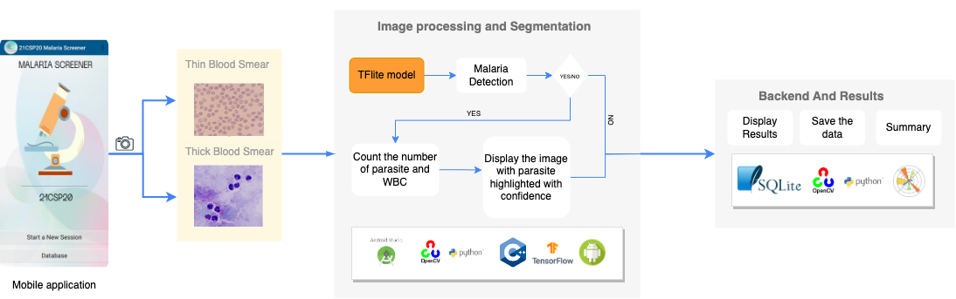
The system consists of the following basic blocks:
Figure 6 System Architecture
- Smear Selection: There are two types of blood smears necessary for the accurate diagnosis of the disease, so there is an option for the selection of smear type. Thin smears involve the counting of red blood cells (RBCs) and identification of potential parasites, while thick smears entail the counting of white blood cells (WBCs) and parasites. A high count of WBCs may indicate an infection in the blood.
- Image Processing and Segmentation: The step involves image preprocessing, which enhances sample quality by adjusting the brightness, contrast, and color balance of the image. Following that, image segmentation is conducted to identify and separate individual cells within the image. After segmenting the cells, the model analyzes each one to determine the presence of malaria parasites. If parasites are detected, the model counts the number of infected cells and parasites in the image, providing this information as output. On the other hand, if no parasites are identified, the model reports that there were no parasites detected in the image.
- Backend and Results: The results of the model are saved in an SQLite database along with the patient information, allowing for easy storage and retrieval of data. This information can be uploaded to the cloud for safekeeping or can be deleted to maintain patient confidentiality. Additionally, the images collected during the detection process can be fed back into the model to improve its accuracy over time.

Dataflow Diagram
The application captures an image of the blood smear, which can be obtained either through the device's camera or from the storage. The image undergoes image segmentation and processing to convert it into the desired resolution and quality. Subsequently, the processed image is fed into the model for classification, which provides information on the infection status, the number of RBCs, WBCs, and parasites present in the blood. Patient information is collected, and a summary report is generated, displaying the sample result to the user. The report is stored in the database for future reference.
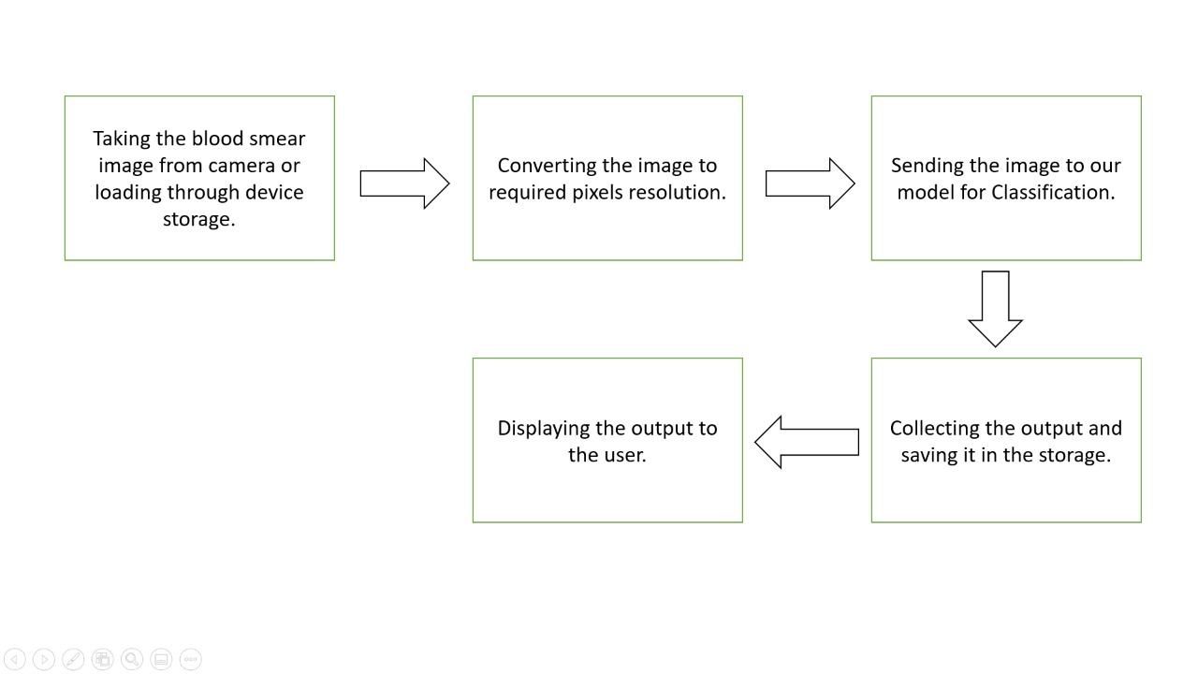
Figure 7 Dataflow Diagram
The application captures an image of the blood smear, which can be obtained either through the device's camera or from the storage. The image undergoes image segmentation and processing to convert it into the desired resolution and quality. Subsequently, the processed image is fed into the model for classification, which provides information on the infection status, the number of RBCs, WBCs, and parasites present in the blood. Patient information is collected, and a summary report is generated, displaying the sample result to the user. The report is stored in the database for future reference.

Usecase Diagram
- The user provides a blood smear image as input to the system through a camera or uploaded from a device.
- The system uses computer vision techniques to preprocess the image, such as removing noise and enhancing contrast.
- The preprocessed image is fed into a machine learning model trained to detect malaria parasites in blood smears.
- The machine learning model analyses the image and detects the presence of malaria parasites.
- The output is presented to the user, indicating whether malaria parasites were found in the blood smear and at what level of infection.
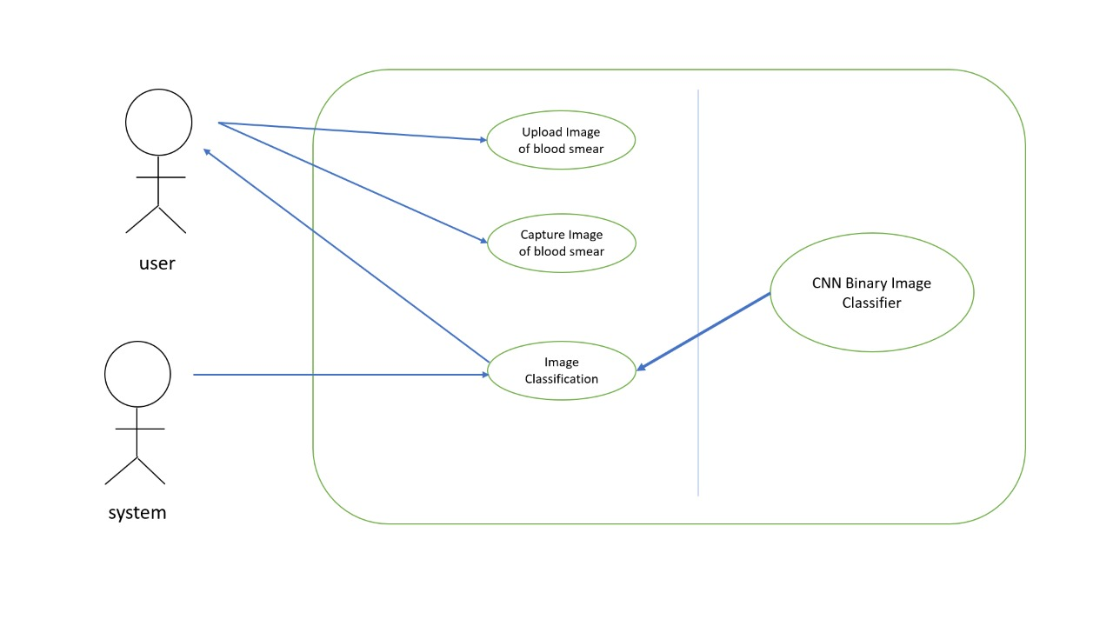
Figure 8 Use case Diagram

Activity Diagram
This system for detecting malaria in blood smears uses computer vision techniques to pre-process images, such as removing noise and enhancing contrast. The pre-processed image is then fed into a machine learning model trained to detect malaria parasites in blood smears, which analyses the image to detect the presence and level of infection of malaria parasites. The output is then presented to the user, providing information on the detection of malaria parasites in the blood smear:
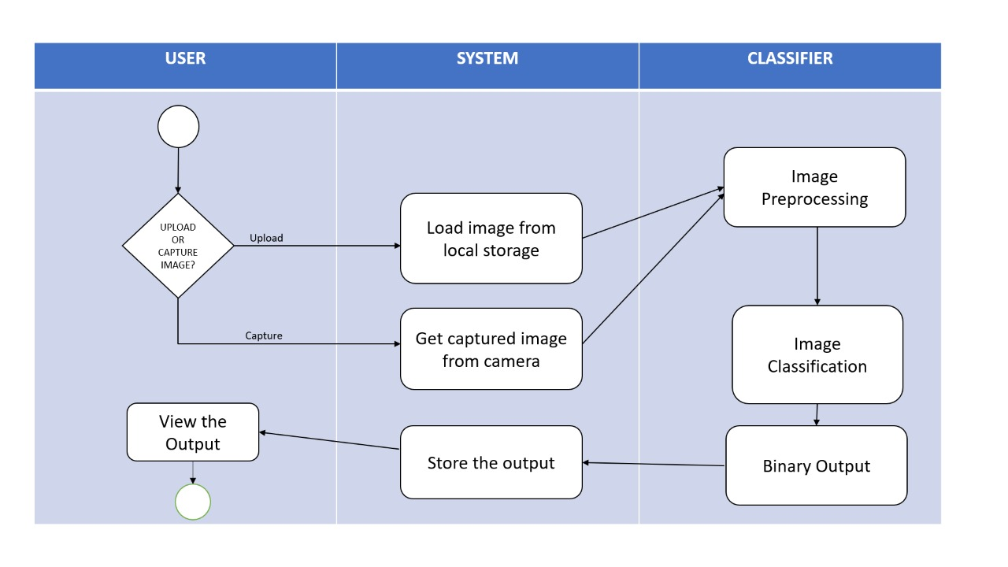
Figure 9 Activity Diagram
This system for detecting malaria in blood smears uses computer vision techniques to pre-process images, such as removing noise and enhancing contrast. The pre-processed image is then fed into a machine learning model trained to detect malaria parasites in blood smears, which analyses the image to detect the presence and level of infection of malaria parasites. The output is then presented to the user, providing information on the detection of malaria parasites in the blood smears

CHAPTER 5:

IMPLEMENTATION

Methodologies
The application consists of two distinct modules, as seen in Figure 10, namely the Screening Module and the Data Storage Module. The Screening Module is the main component of the application and comprises three sub-modules. The first sub-module is the Image Acquisition Module, which captures the image of the blood sample by utilizing the Android Camera API. The image captured by the acquisition module is passed to the second sub-module is the Parasite Detection Module, which leverages TensorFlow Lite and OpenCV Android to detect parasites in the blood sample. The detection module detects if the parasite is present in the image and if present counts the number of RBCs, WBCs and the parasites numbers. Finally, the third sub-module is the Result Module, which employs the Android GUI to display the test results. The Data Storage and Retrieval Module utilizes SQLite to store and retrieve patient data, including images from the slides, as well as a summary of the report. The data storage module stores the data from the same patient in the same table which helps in easier retrieval of the data.
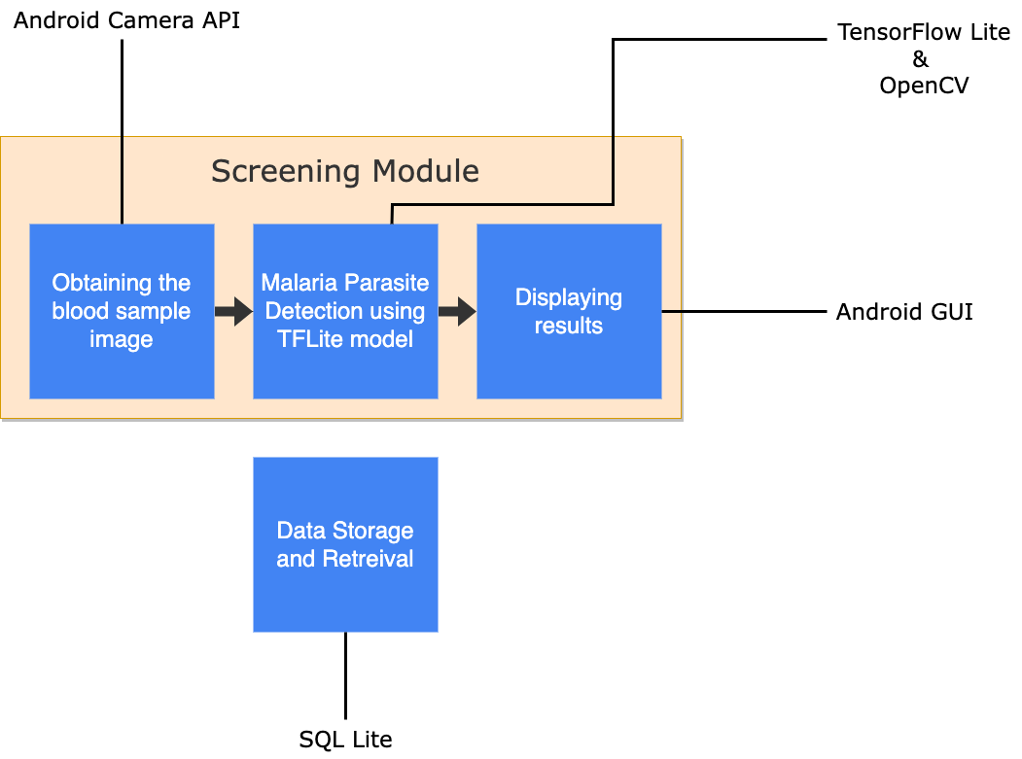
Figure 10 Application Architecture

Description of Process
The process of detecting malaria begins with the user opening the application on their Android device and capturing an image using the device's camera. The captured image then undergoes pre- processing operations such as noise removal and contrast enhancement in the OpenCV module before being passed to the parasite detection module. This module utilizes a TensorFlow Lite model that has been trained to identify malaria parasites in blood smears. The model scrutinizes the image and detects the presence of malaria parasites with precision.

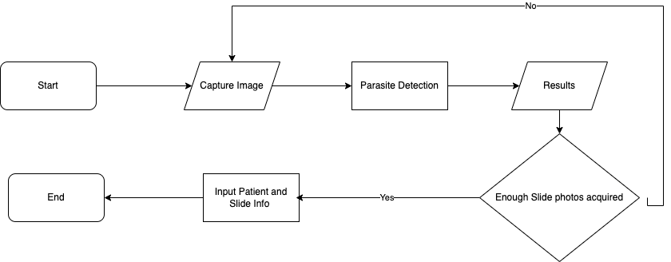
Figure 11 Workflow of the Application

The process of detecting malaria begins with the user opening the application on their Android device and capturing an image using the device's camera. The captured image then undergoes pre- processing operations such as noise removal and contrast enhancement in the OpenCV module before being passed to the parasite detection module. This module utilizes a TensorFlow Lite model that has been trained to identify malaria parasites in blood smears. The model scrutinizes the image and detects the presence of malaria parasites with precision.
For accurate diagnosis of the disease, there are two types of blood smears required, and the app offers an option to select the type of smear needed. Thin smears necessitate counting red blood cells (RBCs) and identifying potential parasites, while thick smears require counting white blood cells (WBCs) and parasites. If the user has not captured the necessary number of slides, the system prompts them to continue capturing images until the required number is obtained. Once the required number of slides have been captured, the user is prompted to input patient particulars, which are then stored in an SQLite database for future reference.
The image processing and segmentation stage involves pre-processing the image to improve the sample's quality by adjusting brightness, contrast, and colour balance. Then, image segmentation is performed to recognize and segregate individual cells within the image. After cell segmentation, the model scrutinizes each cell to determine the presence of malaria parasites. If parasites are
identified, the model counts the number of infected cells and parasites in the image and outputs this information. In the case of no parasites being detected, the model reports that no parasites were identified in the image.
The results generated by the model are saved in an SQLite database, along with the patient's information, making it easier to store and retrieve data. The information can be uploaded to the cloud for safekeeping or deleted to maintain patient confidentiality. The images collected during the detection process can be fed back into the model to enhance its accuracy over time.

CHAPTER 6:

RESULTS

Model Architecture
To create the Deep Learning Model to detect malaria in the blood cells, we took the images from the dataset and fed through a CNN model. With an error with the first attempt resulting in spikes in accuracy, we had to explore a second model with a more efficient architecture and accuracy.

First Attempt
Keras was used to construct a Convolutional Neural Network (CNN) model which incorporated a total of 17 layers as shown in Figure 13, including convolution layers designed to extract features, batch normalization layers used to normalize data, max pooling layers to down sample data, flattening layers used to convert the output of convolution layers to a 1D array, and dense layers for classification.
To import images directly from a folder into the model, we used Keras Flow from directory. This approach allowed for the speedy and efficient loading and processing of a vast number of images. Prior to feeding the image to the model , we pre-processed input images using normalization and data augmentation techniques to enhance model performance.
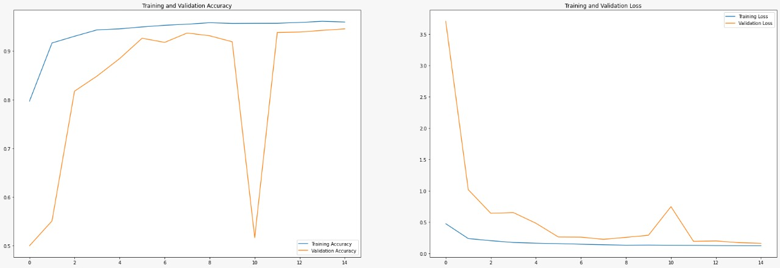
The output of the model was a dictionary containing the images and their respective classified values. A value of 0 signified the absence of malaria parasites in the blood smear image, while a value of 1 indicated their presence. This approach gave us the validation accuracy and loss as seen in Figure 12.
Figure 12 Validation Accuracy and Loss of the First Model

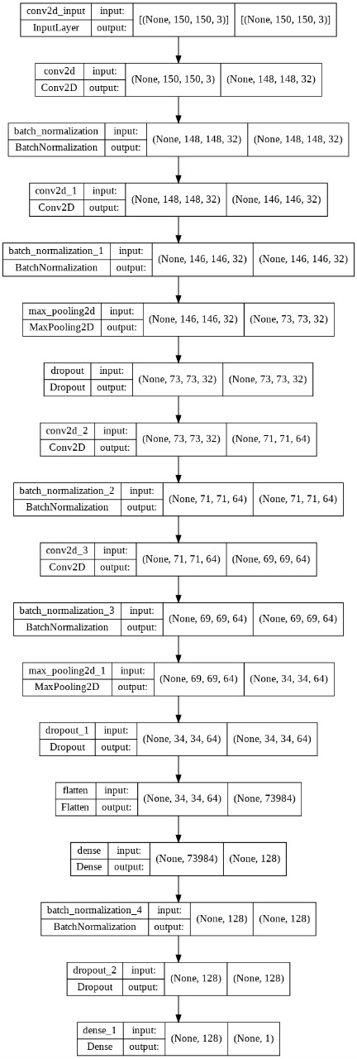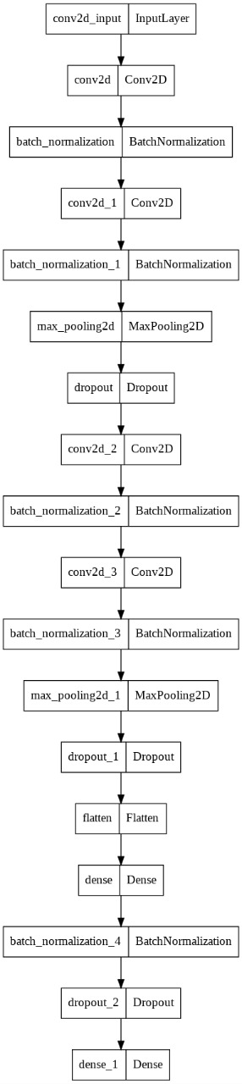
Figure 13 Model Architecture of the First Attempt

During the development of our malaria detection model, we noticed some issues with the validation testing during the 11th epoch. Upon investigation, we discovered that our model, which is a binary classifier used to identify parasitized and uninfected cells, had an accuracy threshold between 49% to 51%.
Initially, the model generated a dictionary with pairs of image and values, where 0 indicated an infected cell and 1 indicated an uninfected cell. However, as time went by, the model started to experience confusion during classification and defaulted back to the accuracy threshold, which resulted in spikes during the 11th epoch.
To address this issue, we developed a new model that took into account this problem. With this new model, we were able to improve the performance of our malaria detection system and correctly classify blood smear images as either containing or not containing malaria parasites.

Second Attempt
For our second attempt at constructing a malaria detection model, we decided to simplify the architecture by decreasing the number of layers and modifying our approach to inputting images and labels into the model. Rather than using a dictionary, we utilized a class function of x and y, where x represented the image, and y indicated the label (either infected or uninfected blood smears). This alteration allowed the model to classify images based on their percentage, resulting in a greater accuracy in detecting infected or uninfected blood smears. We accomplished this by training the model to optimize the weights and biases using the input values of x and y.
For our second attempt at constructing a malaria detection model, we decided to simplify the architecture by decreasing the number of layers and modifying our approach to inputting images and labels into the model. Rather than using a dictionary, we utilized a class function of x and y, where x represented the image, and y indicated the label (either infected or uninfected blood smears). This alteration allowed the model to classify images based on their percentage, resulting in a greater accuracy in detecting infected or uninfected blood smears. We accomplished this by training the model to optimize the weights and biases using the input values of x and y.

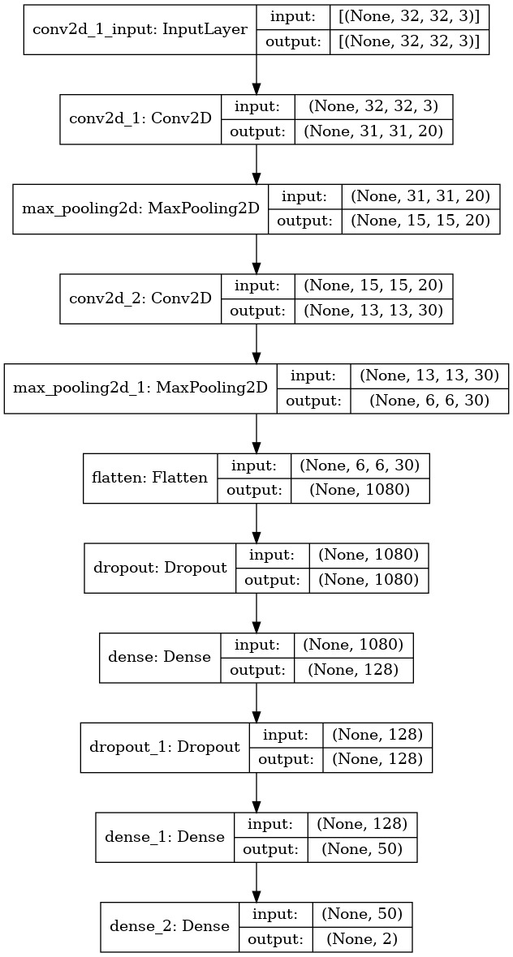
Figure 14 Model Architecture of Second Attempt

We leveraged the percentage values given by the model on what it thinks the class of the image was and trained the model to effectively classify blood smear images as either containing or not containing malaria parasites based on which class confidence percentage is higher. The confidence method refers to a statistical strategy that is commonly utilized to evaluate the precision of forecasts generated by a model. This methodology involves assessing the degree of uncertainty in the model's output by estimating the probability of errors in the predictions. To achieve this, the distribution of errors across the forecasts is measured, and the variance of these errors is calculated. The confidence method is especially valuable in machine learning, where models are employed to generate predictions based on extensive datasets. By quantifying the accuracy of the model's predictions, the confidence method can help to pinpoint the areas of the dataset where the model may be less precise and thus require further refinement or training. This strategy mitigated the erratic behaviour observed in our previous approach. With the percentage value, the model could accurately label the images as infected or uninfected, and confusion was eliminated. The validation accuracy and loss obtained with this process is shown in Figure 15:

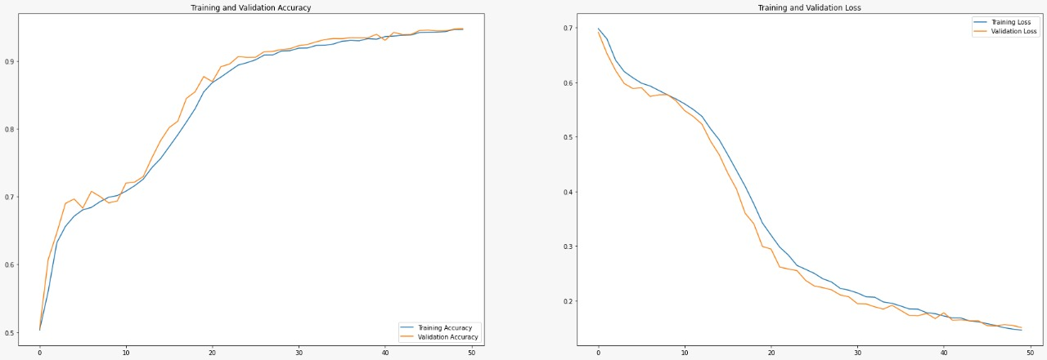
Figure 15 Validation Accuracy of the Second Model

This can be further seen as a confusion matrix as in Figure 16 below:
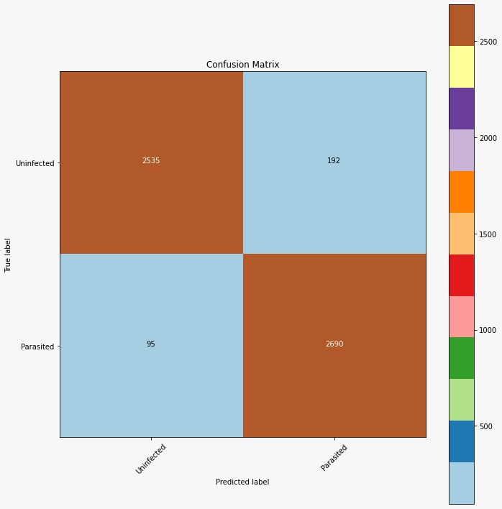
Figure 16 Confusion Matrix

Android Application
Upon launching the application, the user is presented with a welcome screen as in Figure 17 that provides two options: either to commence a new session or to access the database. If the user decides to initiate a new session, they are prompted to specify the type of blood smear they wish to examine, pictured in Figure 18. The application offers two choices for the user, namely Thick Smear and Thin Smear. Thick Smear detects both parasites and white blood cells (WBCs), whereas Thin Smear identifies red blood cells (RBCs) and malaria-infected blood cells.
After selecting the desired type of blood smear, the user is required to capture cell images until they acquire the required number of cells, which they can modify as per their preferences. The captured images undergo detection to identify the presence of parasites in the blood sample using the model. In the event that no parasites are detected in the sample, the model indicates as such. However, if parasites are detected in the image, the model counts their quantity and highlights them using varying coloured circles that represent its confidence in the detection. The highlighted parasites in the blood samples can be seen in Figure 19 with the confidence scale.

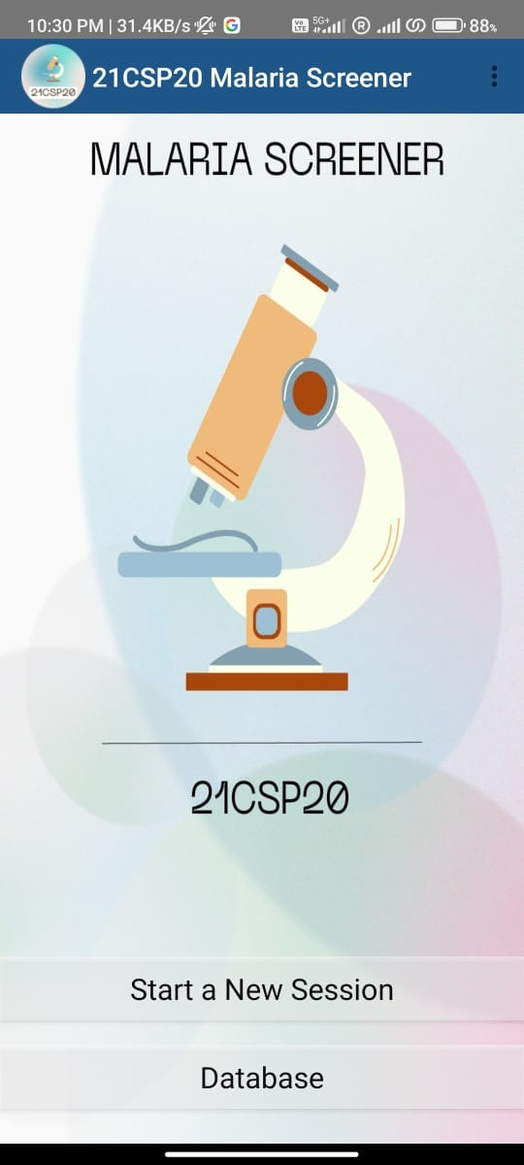
Figure 17 Welcome Screen

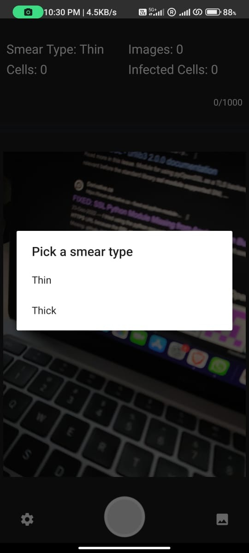
Figure 18 Choose Smear Type

Figure 16 Choose Smear Type
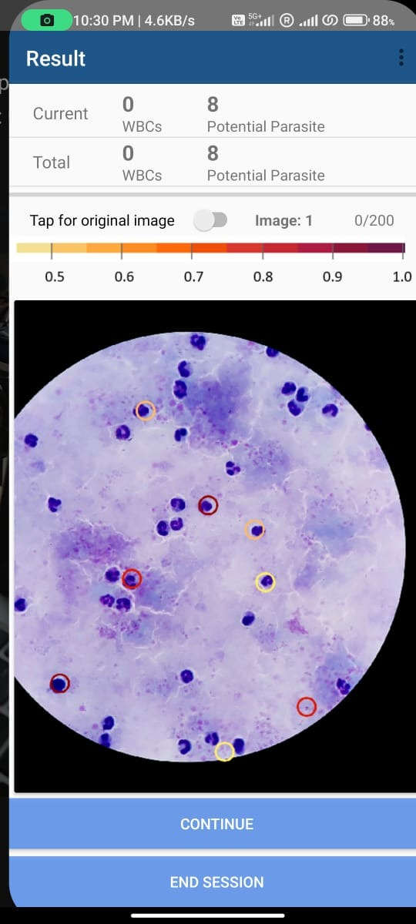
Figure 19 Thick Smear Blood Sample

Following the end of a session, the malaria detection application prompts the user to input patient information as well as slide information as in Figure 20 and Figure 21. The patient information and slide information are subsequently stored in a database using the patient ID as a unique identifier. The slide information is stored in a separate table that includes details such as the slide type (thin or thick), the number of infected cells, and the detected parasites which can be seen in Figures 23, 24 & 25.
After the necessary information is collected, the application generates a summary report for the user. The summary report pictured in Figure 22 includes information on the diagnosis, whether it is positive or negative, as well as the cell counts for each slide type. The collected slides are then saved in the database, allowing for easy access at any time and the ability to be deleted as needed.
Furthermore, the database can be exported as a CSV file, thereby enabling further processing and analysis of the data. This feature provides the flexibility for researchers or healthcare providers to analyse the data outside of the application.
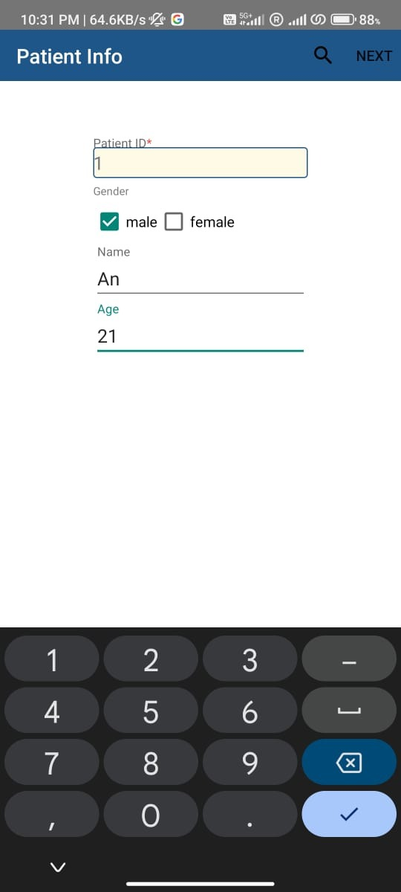
Figure 20 Collect Patient Info
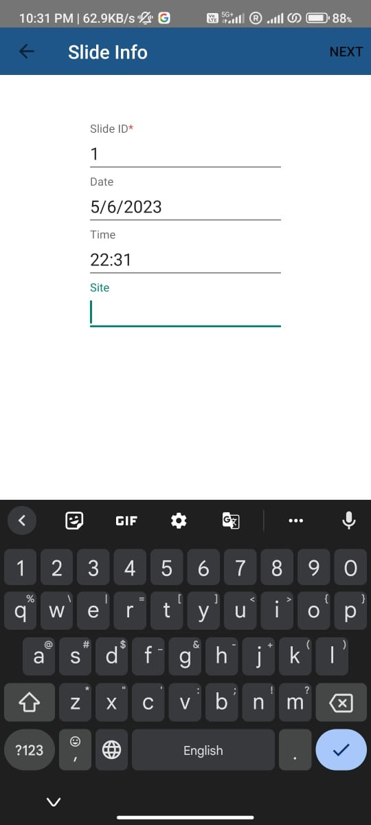
Figure 21 Collect Slide Info

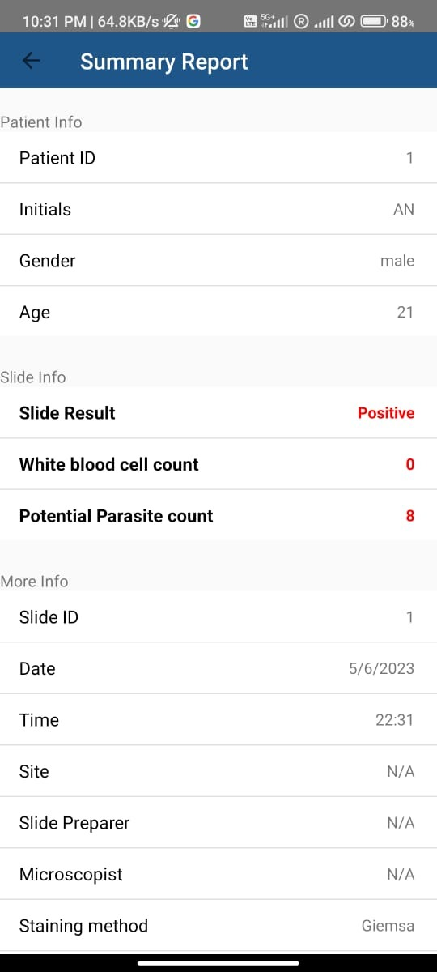
Figure 22 Report Summary
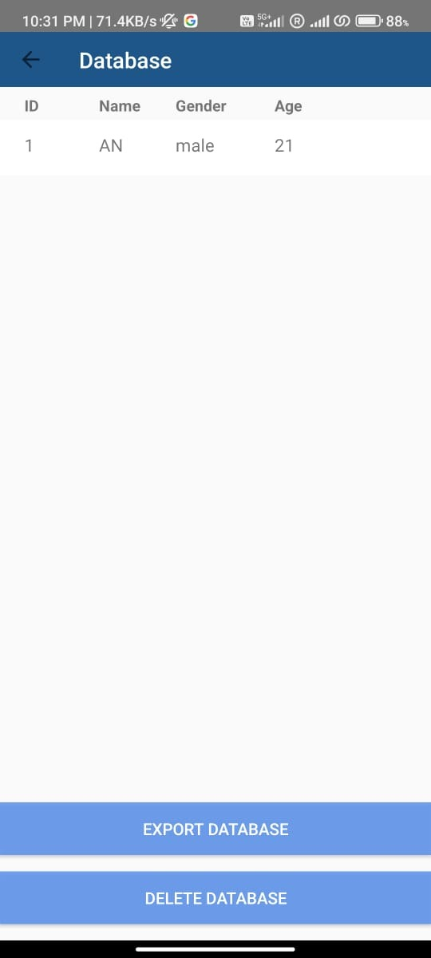
Figure 23 Database
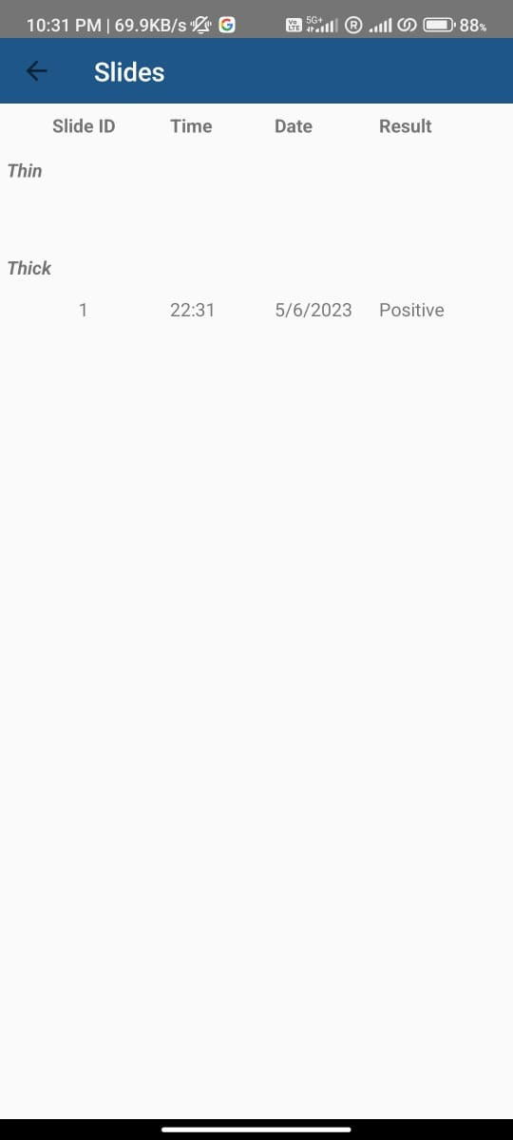
Figure 24 Slide Info
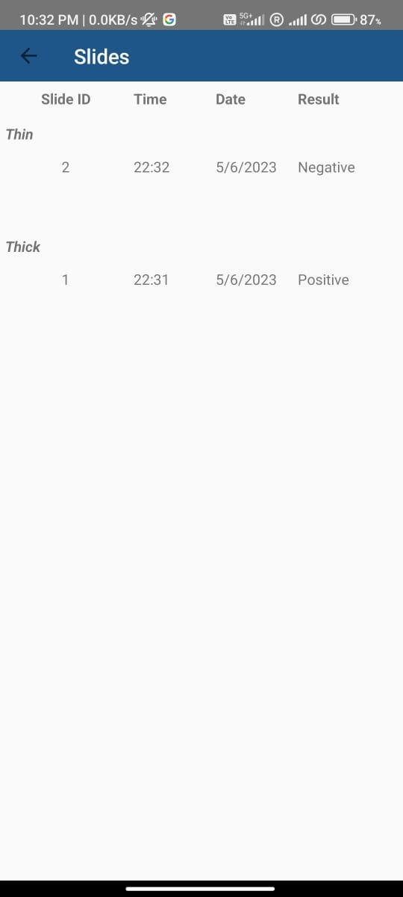
Figure 25 Slide Info with both smear types

Figure 23 with both blood types

Webapp
For tracking the progression of the disease, we must isolate the parasite within the cell which requires image segmentation. The process for segmentation of the image requires huge computational power. So, we decided to make a webapp to track the progression of the parasite within the blood cell. Using the findContour () function from OpenCV we can make bounding boxes around the parasite and the blood sample and then find the area of said bounding boxes. Using that resulting area of the parasite and the blood cell, we can find the ratio of the parasite to the blood. According to our test sample of 100 images with 57 images of the Ring Stage and 43 images of the Schizont Stage we had the results for the average area tabulated in Table 1.
Table 1 Area of the Blood Samples
Blood Sample | Avg. Area of Blood Cell | Avg. Area of Parasite
Initial Ring Stage | 13786 | 464.167
Advanced Schizont Stage | 14617.8 | 1309

Ring Stage | Schizont Stage
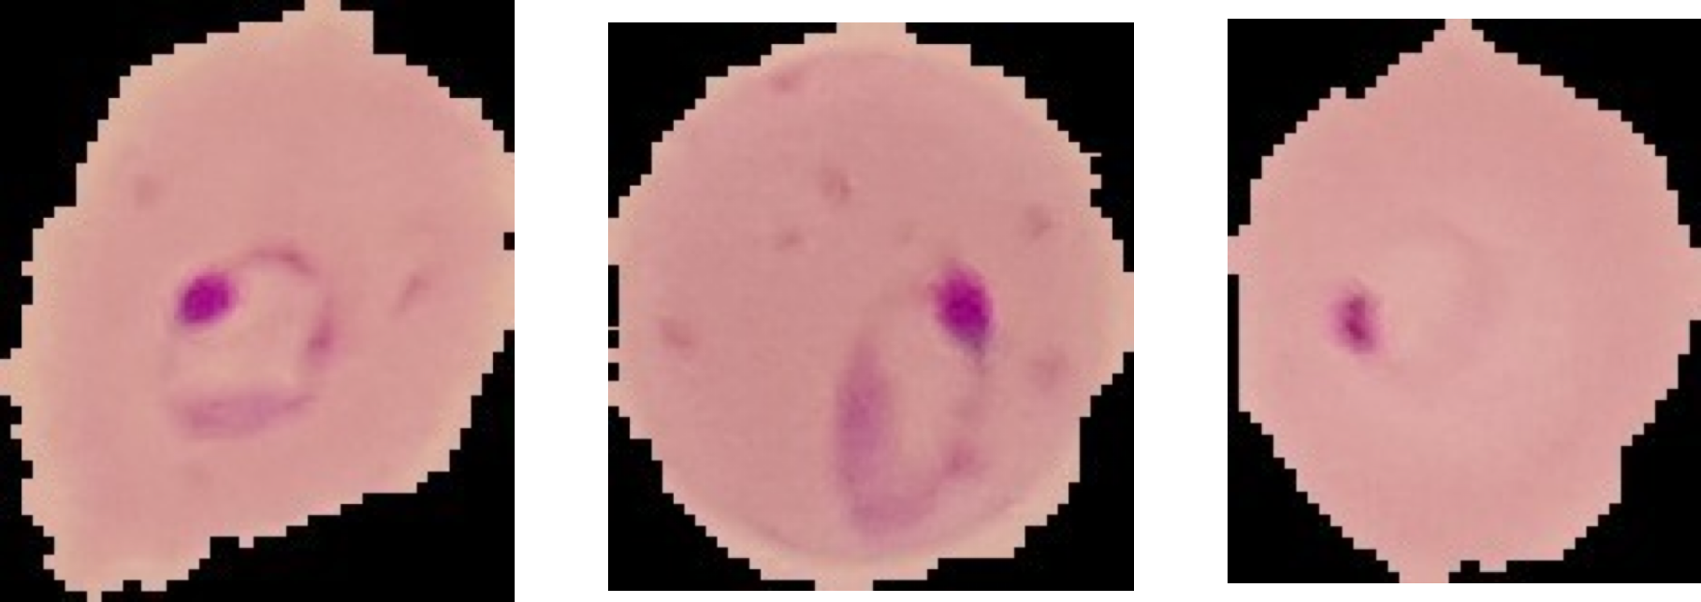 | 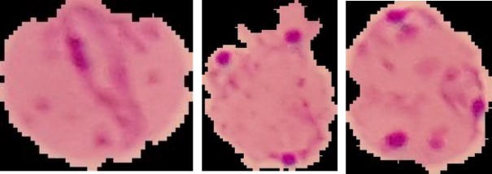
So, with this data we concluded that if the parasite has less than 8% coverage of the blood sample then it can be classified as Initial Ring Stage and any coverage larger than 8% then it can be classified as the Advanced Schizont Stage. As our model is based on finding the area of the parasites in the blood sample, it is harder to track the progression more than these two.
Table 2 Ring and Schizont Stage
In the webapp we have a real-time malaria data showcased as in Figure 26 to tell the numbers of cases happening all over the world as well as the progression of the cases number with ongoing years. The webapp can also take in the images from the user to predict for the parasite as well as tell the stage of the disease as shown in Figure 27 and Figure 28.
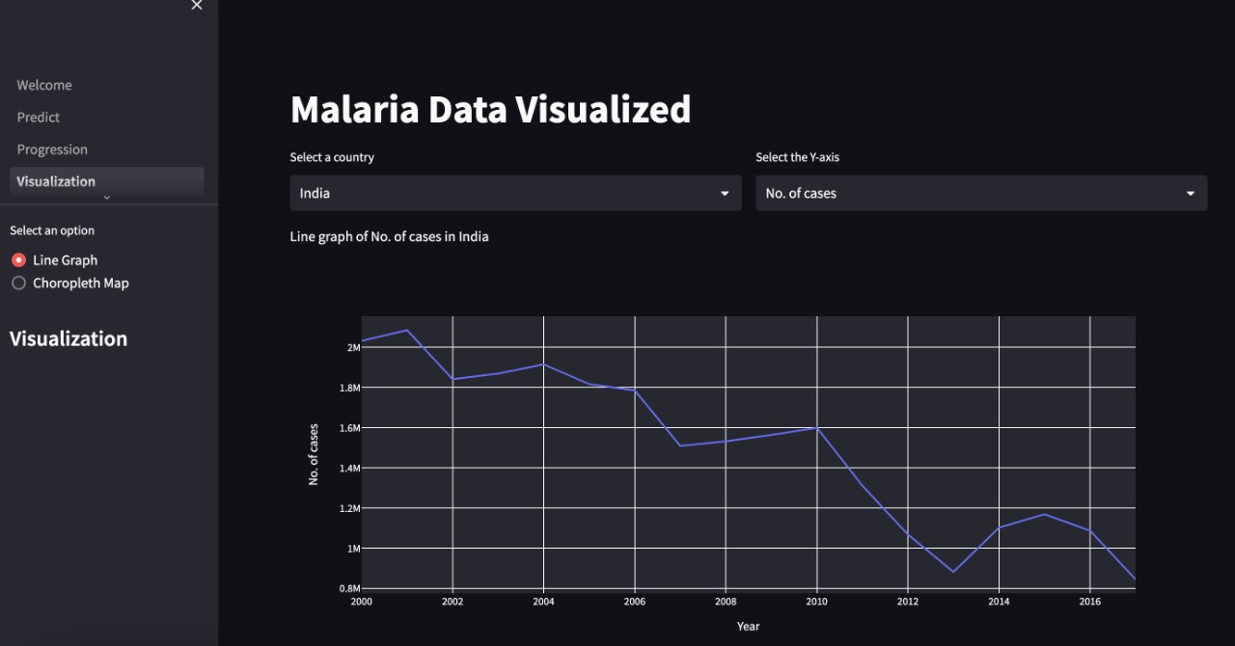
Figure 26 Realtime Malaria Data

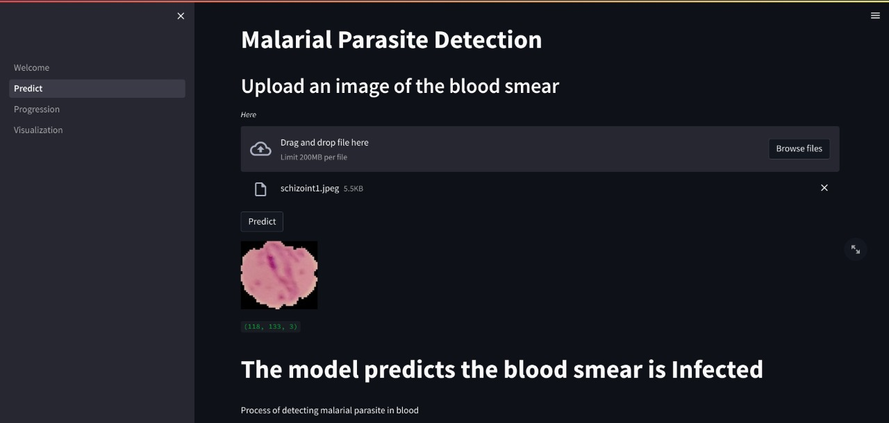
Figure 27 Webapp Predict Page

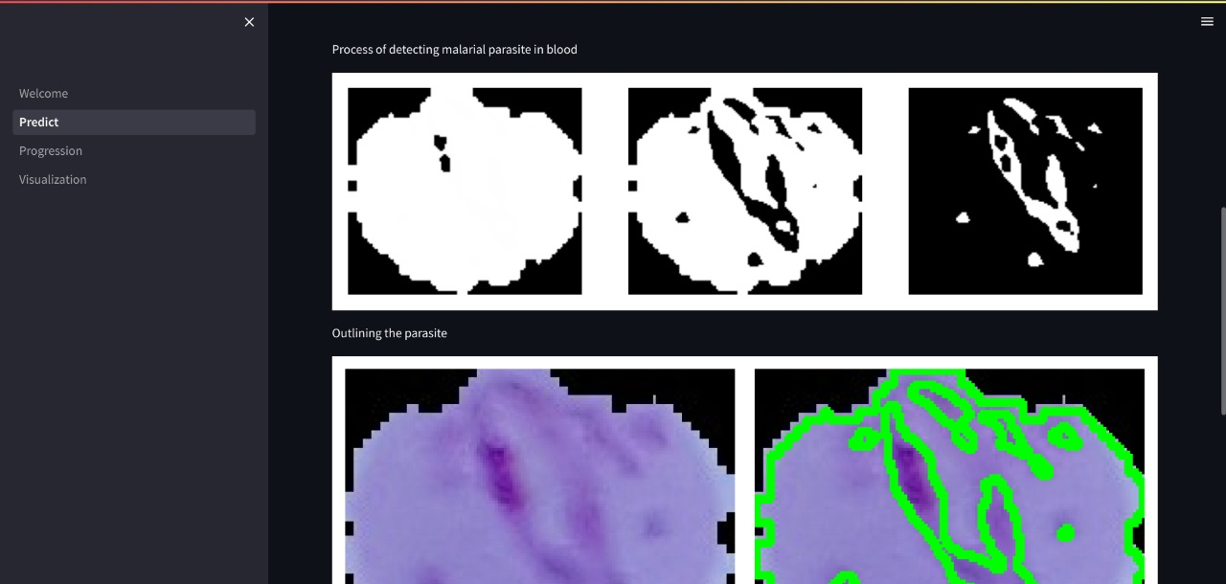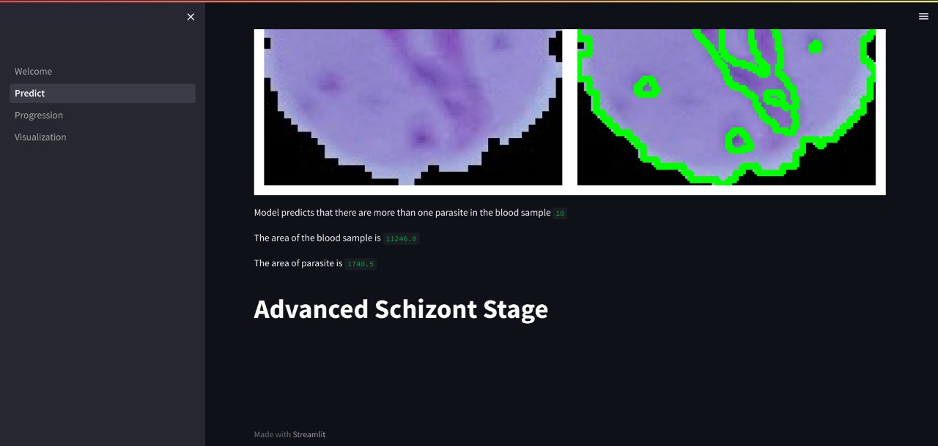
Figure 28 Tracking the Progression of the Disease

CHAPTER 7:

IMPACT OF OUR PROJECT TOWARDS SOCIETY/ ENVIRONMENT
The impact of our malaria detection application on society and the environment is considerable. Malaria is a lethal illness that affects millions of people worldwide, especially in low-income countries. Our project is designed to enhance the precision and availability of malaria detection, providing healthcare professionals with an effective tool to diagnose and treat malaria promptly.
Through the utilization of computer vision techniques and machine learning algorithms, we are able to decrease the cost and time required for diagnosis, while also providing more accurate and dependable results. This approach helps to increase the likelihood of successful treatment and reduce the transmission of the disease, resulting in improved health outcomes for individuals and communities.
In addition, our application has a favourable impact on the environment. Traditional diagnostic techniques for malaria detection often require the use of hazardous chemicals and materials. By providing an alternative method that relies on computer vision techniques and machine learning algorithms, we are reducing the quantity of hazardous materials used in the diagnostic process. This has a positive effect on the environment by decreasing the risk of chemical exposure and contamination.
Furthermore, our application has the potential to enhance healthcare outcomes in rural and remote areas, where access to healthcare services and diagnostic equipment may be limited. By providing an efficient and accessible tool for malaria detection, we are assisting in the improvement of health outcomes for individuals in these areas, while also lessening the burden of the disease on their communities.

CHAPTER 8 :

CONCLUSIONS
Malaria is a pressing public health issue in developing nations, caused by the Plasmodium parasite transmitted via the bite of infected mosquitoes. Despite the availability of several diagnostic techniques, they are not accessible to everyone, particularly in remote and rural areas, making it challenging to control the disease. However, Convolutional Neural Networks (CNNs), a form of deep learning, has demonstrated significant potential in various fields, including medical image analysis. By employing CNNs to analyse and segment images from low-cost and portable foldscopes, it is possible to detect the presence of Plasmodium in blood smears.
The CNN-based malaria diagnostic system has the potential to reduce the cost of diagnosing malaria by replacing bulky and expensive microscopes. Additionally, by providing an early diagnosis, it enables prompt treatment, potentially saving lives and decreasing the economic burden of the disease. CNNs' modularity also allows for additional modules to detect other vector- borne diseases, such as those that cause dengue and Zika.
To summarize, the CNN-based malaria diagnosis system, using foldscopes to analyse and segment images, offers an accessible and cost-effective tool for malaria diagnosis in resource-limited settings. By providing accurate and timely diagnoses, it could potentially help reduce the morbidity and mortality associated with malaria and other vector-borne disease.

CHAPTER 9:

REFERENCES

- WHO, World Malaria Report, Geneva, Switzerland, 2016.
- Magotra, Varun, and Mukesh Kumar Rohil. “Malaria Diagnosis Using a Lightweight Deep Convolutional Neural Network.” International Journal of Telemedicine and Applications, vol. 2022, 15 Apr. 2022, pp. 1–8, www.ncbi.nlm.nih.gov/pmc/articles/PMC9033338/,
https://doi.org/10.1155/2022/4176982.
- Greco, D. (2021, December 6). Six Trends in Data Storage, Protection & Resilience. WWT. https://www.wwt.com/article/six-trends-in-data-storage-protection-and-resilience
- Kumar, Sumit, et al. Malaria Detection Using Deep Convolution Neural Network. 2023.
- Siłka, Wojciech, et al. “Malaria Detection Using Advanced Deep Learning Architecture.” Sensors, vol. 23, no. 3, 29 Jan. 2023, p. 1501, https://doi.org/10.3390/s23031501.
- Mehta, P., Wang, C. H., Day, A., Richardson, C., Bukov, M., Fisher, C. K., & Schwab, D. J. (2019). A high-bias, low-variance introduction to Machine Learning for physicists. Physics reports, 810, 1–124. https://doi.org/10.1016/j.physrep.2019.03.001
- Burns, E. (2021a, March 30). machine learning. SearchEnterpriseAI. https://www.techtarget.com/searchenterpriseai/definition/machine-learning-ML
- F. (2021, November 4). How to select a machine learning algorithm - Azure Machine Learning. Microsoft Docs. https://docs.microsoft.com/en-us/azure/machine-learning/how-to-select-algorithms
- Evans, R S. “Electronic Health Records: Then, Now, and in the Future.” Yearbook of medical informatics vol. Suppl 1, Suppl 1 S48-61. 20 May. 2016, doi:10.15265/IYS-2016-s006
- Bostock, M., & Bostock, M. (2014). Visualizing Algorithms. Https://Bost.Ocks.Org/Mike/. https://bost.ocks.org/mike/algorithms/
- https://www.slideshare.net/ananthatulasi/foldscope-introduction-and-application-by-drchtulasi
- Wikipedia contributors. (2021, December 24). Foldscope. Wikipedia. https://en.wikipedia.org/wiki/Foldscope
- Rosado, Luís & Correia da Costa, José Manuel & Elias, Dirk & Cardoso, Jaime. (2016). Automated Detection of Malaria Parasites on Thick Blood Smears via Mobile Devices. Procedia Computer Science. 90. 138-144. 10.1016/j.procs.2016.07.024.
- Guo, Xin, et al. “Smartphone-Based DNA Diagnostics for Malaria Detection Using Deep Learning for Local Decision Support and Blockchain Technology for Security.” Nature Electronics, vol. 4, no. 8, 1 Aug. 2021, pp. 615–624, www.nature.com/articles/s41928-021- 00612-x, https://doi.org/10.1038/s41928-021-00612-x
- Dutta, Gorachand. “Electrochemical Biosensors for Rapid Detection of Malaria.” Materials Science for Energy Technologies, vol. 3, 2020, pp. 150–158, https://doi.org/10.1016/j.mset.2019.10.003.
- Pirnstill CW, Coté GL. Malaria Diagnosis Using a Mobile Phone Polarized Microscope. Sci Rep. 2015 Aug 25; 5:13368. Doi: 10.1038/srep13368. PMID: 26303238; PMCID: PMC4548194.
- Canty, M. J. (2014). Image Analysis, Classification and Change Detection in Remote Sensing: With Algorithms for ENVI/IDL and Python, Third Edition (3rd ed.). CRC Press.
- D.N. Breslauer, R.N. Maamari, N.A. Switz, W.A. Lam, D.A. Fletcher Mobile phone based clinical microscopy for global health applications (2009)
- J.A. Quinn, A. Andama, I. Munabi, F.N. Kiwanuka Automated blood smear analysis for mobile malaria diagnosis Mobile Point Care Monitors Diagno Device Design, 31 (2014), p. 115
- A. Skandarajah, C.D. Reber, N.A. Switz, D.A. Fletcher Quantitative imaging with a mobile phone microscope PLoS ONE, 9 (2014)
- C. Dallet, S. Kareem, I. Kale Real time blood image processing application for malaria diagnosis using mobile phones international conference on circuits and systems, IEEE (2014), pp. 2405-2408
- S. Herrera, A.F. Vallejo, J.P. Quintero, M. Arévalo-Herrera, M. Cancino, S. Ferro Field evaluation of an automated RDT reader and data management device for Plasmodium falciparum/Plasmodium vivax malaria in endemic areas of Colombia Malar J, 13 (2014), p. 87

APPENDIX-I: PAPER WITH CERTIFICATES

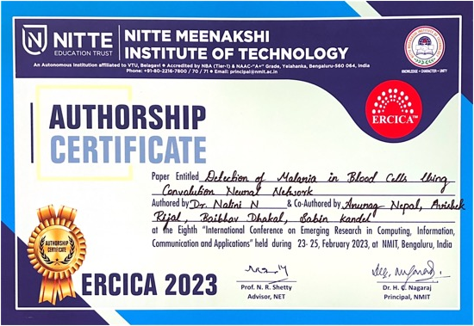

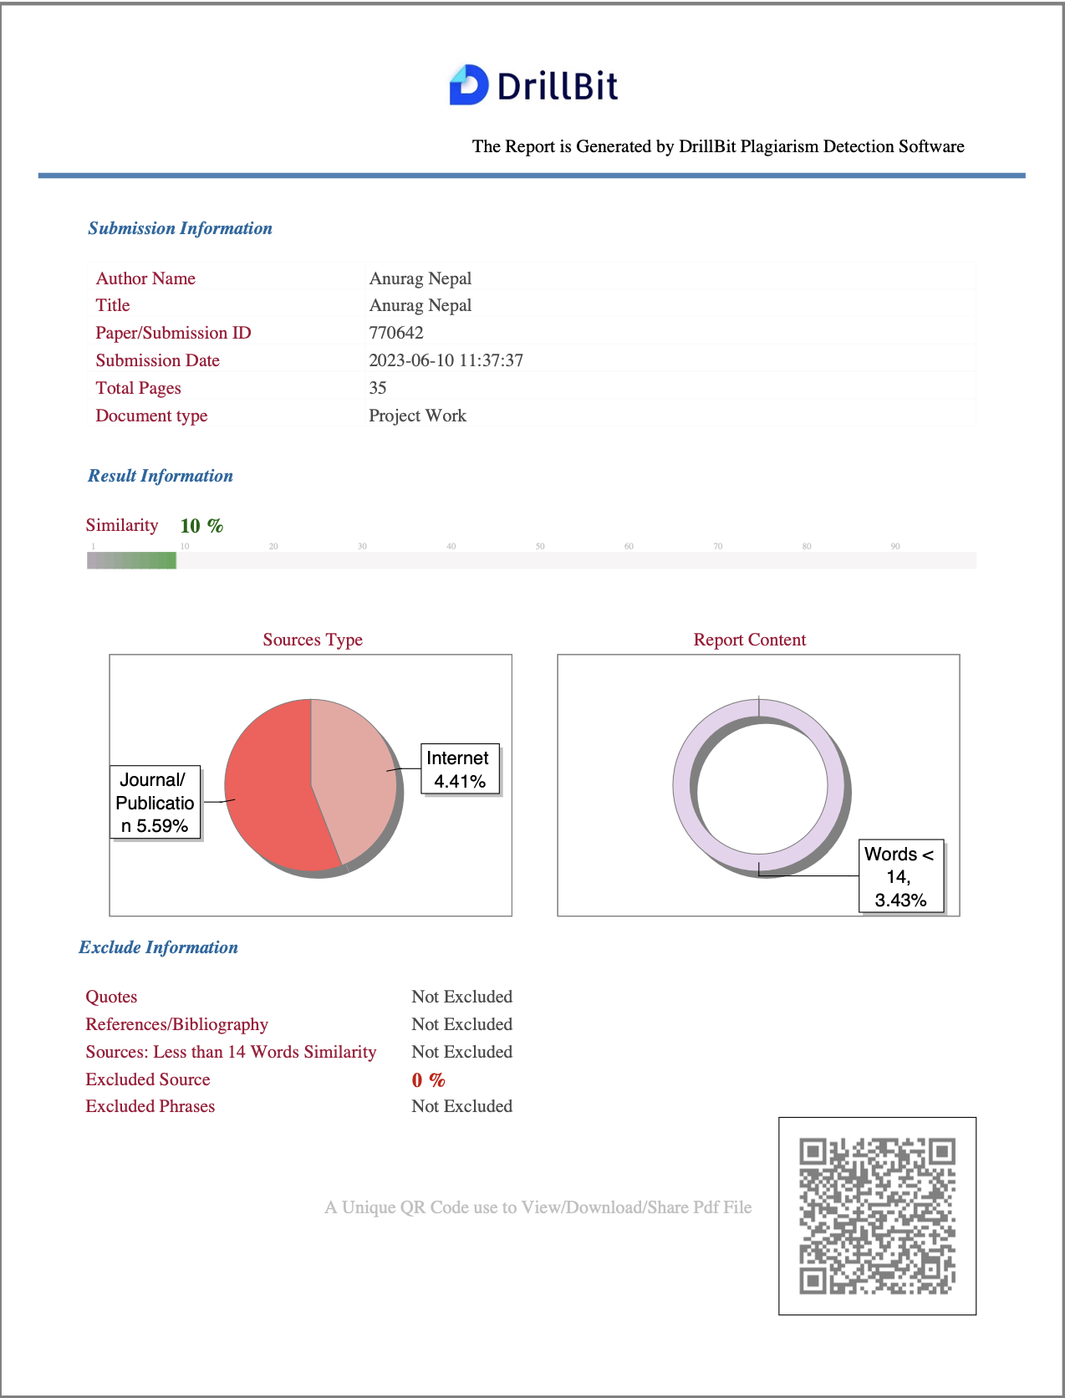
APPENDIX-II:PLAGARISM REPORT

APPENDIX-III: SELF ASSESSMENT OF PO-PSO ATTAINMENT
PO/PSO | Title | Project Mapping
PO1 | Engineering Knowledge | In our project, we utilized our knowledge of computer vision and deep learning algorithms, including Convolutional Neural Networks (CNNs), to design and develop the solution for malaria detection. This included knowledge of image processing techniques, feature extraction, and model training and evaluation.
PO2 | Problem Analysis | We analysed the problem of malaria detection and understood the limitations of current solutions. This involved researching the current state of the art, understanding the requirements and constraints of the problem, and identifying potential solutions.
PO3 | Design Development of solutions | Based on our problem analysis, we designed and developed a solution using CNNs for malaria detection. This involved selecting appropriate algorithms, implementing the model, and testing it on various datasets to evaluate its performance.
PO4 | Conduct investigations of complex problems | We have conducted investigations of complex problems by using research-based knowledge and research methods, including design of experiments, analysis and interpretation of data, and synthesis of information to provide valid conclusions.
PO5 | Modern Tools | We used modern tools in computer vision and deep learning, such as Python and its various libraries (such as TensorFlow, PyTorch, etc.), to implement and train the CNN models.
PO6 | The Engineer and Society | We were aware of the impact of this project on society and ensured that the solution was developed with ethics and social responsibility in mind. This included ensuring that the solution was safe and did not pose any risks to the public and that it was accessible to all people who need it.
PO7 | Environment and sustainability | The project demonstrates an understanding of the impact of professional engineering solutions in societal and environmental contexts, including the need for sustainable development related to malaria detection.
PO8 | Ethics | We adhered to ethical standards and principles when developing the solution for malaria detection. This included ensuring that the solution was developed with integrity and honesty, and that any data collected was used ethically and in accordance with privacy laws.
PO9 | Individual and Teamwork | We were able to work effectively both individually and as part of a team, to complete the project on time and within budget. This involved effective communication and collaboration with team members, as well as managing our own time and resources effectively.
PO10 | Communication | We had strong written and verbal communication skills to effectively communicate with stakeholders and team members. This included being able to explain technical concepts and results to non-technical stakeholders, as well as presenting research findings and progress reports.
PO11 | Project management and finance | We had knowledge of project management principles and were able to manage the project within budget and on schedule. This involved planning and organizing resources, monitoring progress, and making necessary adjustments to ensure the project was completed on time and within budget.
PO12 | Life-long learning | We were committed to lifelong learning and continuously updating our knowledge and skills in computer vision and deep learning, to stay current with the latest advancements and technologies in this field.
PSO1 | Professional Skills | We utilized our professional skills, such as problem-solving, critical thinking, and communication, to effectively analyse the problem and develop a solution for malaria detection.
PSO2 | Problem Solving Skills | We had strong problem-solving skills to identify and resolve any challenges that arose during the development of the solution. This included being able to identify potential solutions and evaluate their feasibility.
PSO3 | Ethics and career development | We were committed to ethical standards and principles in our professional practice, and continuously developed our knowledge and skills to advance our careers in computer vision and deep learning.

